**CENWP-OD-J March 31, 2022**

**MEMORANDUM FOR THE RECORD**

**SUBJECT: 22JDA03 South Fish Turbine Pump #2 out of service**

At 1604 hours on 30 March South fish turbine pump #2 was forced out of service with an excessive vibration issue. John Day maintenance staff believe the vibration to be caused by the impeller shaft being out of alignment in the lower guide bearing pump assembly. This issue was addressed last year with the guide bearing being re-journaled with Teflon strips added to align the shaft properly(see:[21JDA01 MFR South Fish Turbine 2 out of service](http://pweb.crohms.org/tmt/documents/FPOM/2010/NWP%20Memos%20of%20Coordination%20and%20Notification/JDA%20MOC%20and%20MFR/21JDA01%20MFR%20South%20Fish%20Turbine%202%20out%20of%20service.pdf)).

John Day operations immediately started South fish turbine pump #1 and returned the ladder within FPP criteria. Fish turbine pump #2 will have to be dewatered and inspected to assess the severity of the problem and plan a scope of work to fix the issue. At that time an estimated return to service date can be determined.

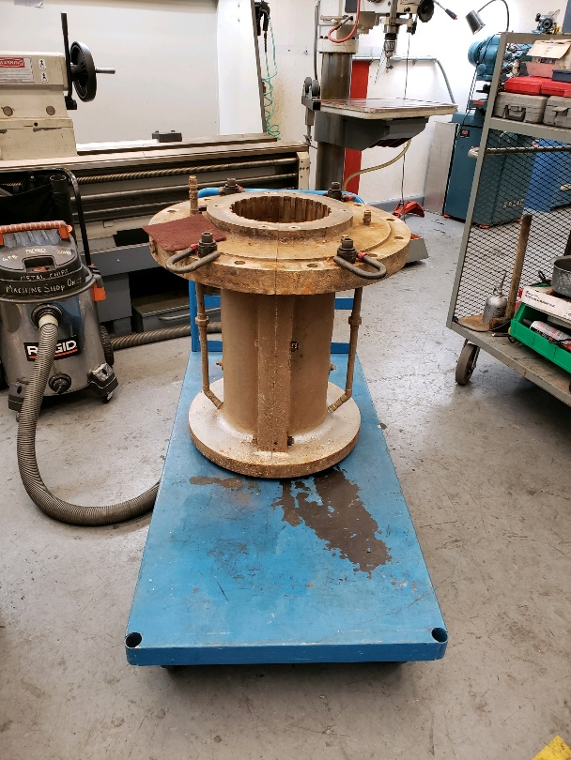

Lower guide bearing

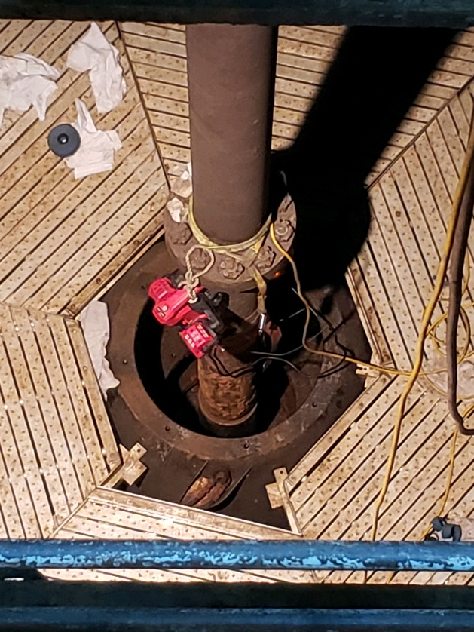

Pump shaft leading to impeller

1. Species –
2. Origin –
3. Length –
4. Marks and tags –
5. Marks and Injuries found on carcass –
6. Cause and Time of Death –
7. Future and Preventative Measures – South fish turbine pump #2 needs an extensive overhaul. Repairs to the lower guide bearing by re-journaling are not a permanent solution.

Sincerely,

JD Project Fisheries